TUGAS MODUL 2

**Praktikum Jaringan Komputer 2022**

**Dosen Pengampu : I Ketut Purnamawan**



**Oleh:**

**DAVID MARIO YOHANES SAMOSIR ; 2115101055 ; ILMU KOMPUTER**

**UNIVERSITAS PENDIDIKAN GANESHA**

**2022**

**Permasalahan**

The report must contain:

1. Theoretical review on the topic.

2. Method/Procedure of practicum.

3. The data obtained.

4. Analysis.

5. Conclusion.

**Jawaban**

1. **Theoretical review on the topic.**

Pada materi ini membahas tentang pengimplementasian jaringan terhadap switcher dan pemberian Ip Address, ketika PC diberi Ip dan terhubung dengan switcher maka PC yang berada di 1 jaringan yang sama dapat berhubungan antara PC 1 dengan PC lainnya, karena switcher ini bisa berfungsi untuk menghubungkan banyak device.

1. **Method/Procedure of practicum.**
2. 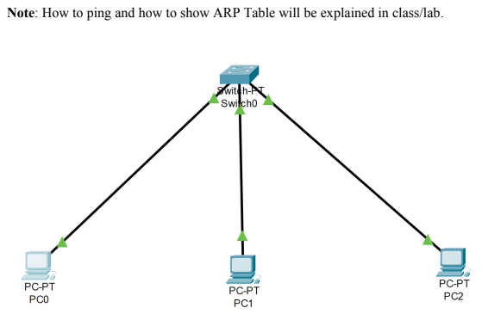**Skenario 1**
3. Buka Aplikasi Cisco Paket Tracer



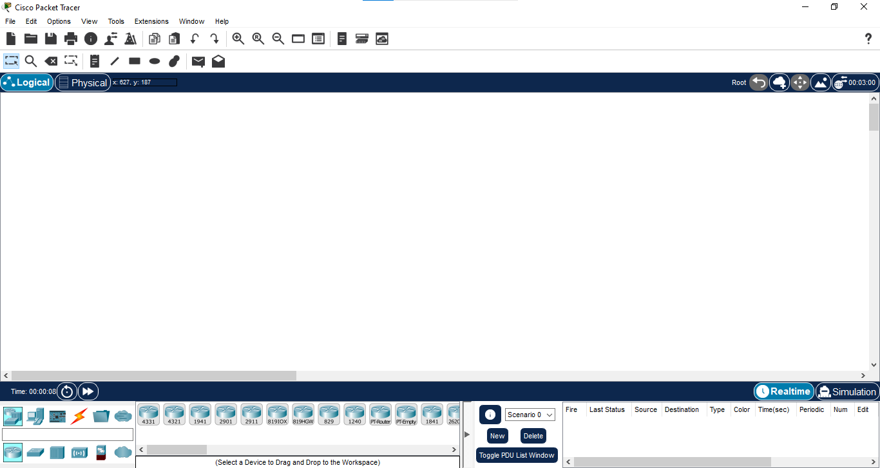

1. Pilih **Network Devices >> Switches >> PT_Switch** lalu letakkan di layar.

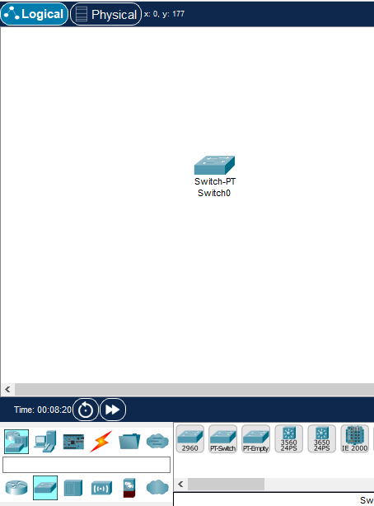

1. Pilih **End Devices >> PC** lalu letakkan di layar, lakukan sebanyak 3x.

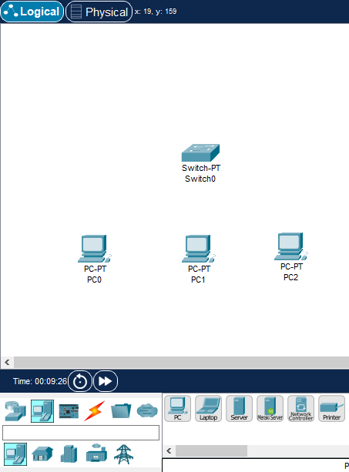

1. Lalu sambungkan PC dengan Switch pilih **Connections >> Staright**

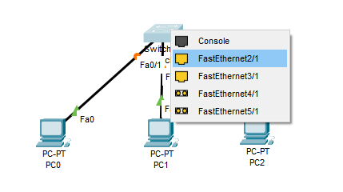

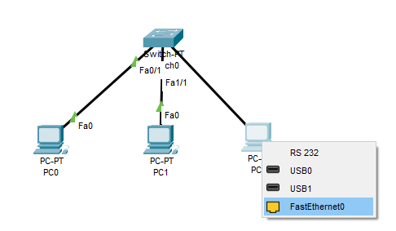

1. Lalu beri Ip Address pada setiap PC

PC0 : 192.168.1.1 / 255.255.255.0

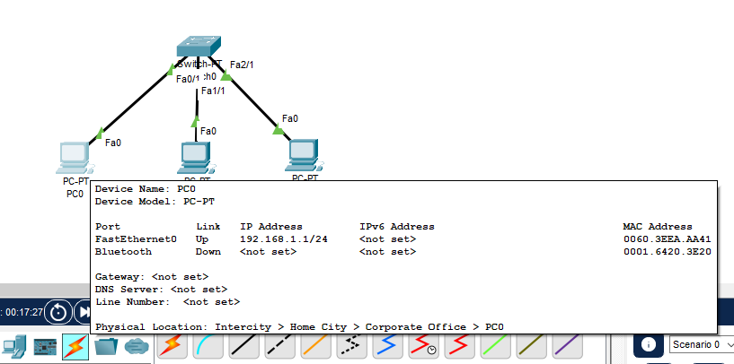

PC1 : 192.168.1.2 / 255.255.255.0

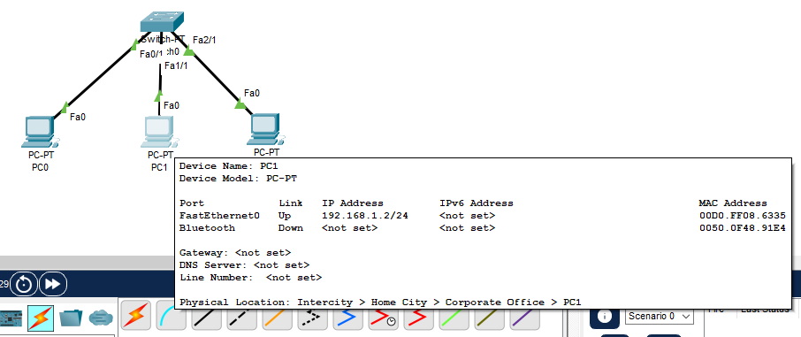

PC2 : 192.168.1.3 / 255/255/2550

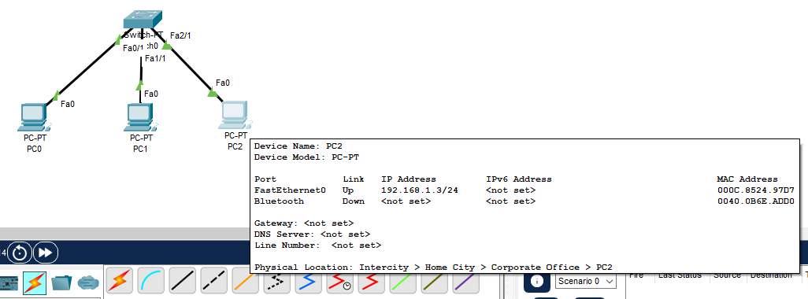

1. Test Ping

* PC0 – 192.168.1.1
* PC0 :

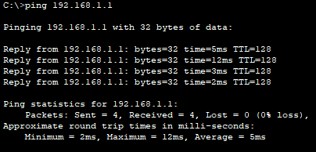

* PC1

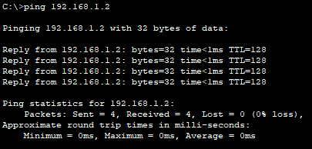

* PC2

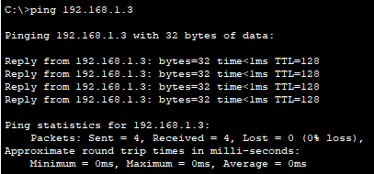

* PC1 – 192.168.1.2
* PC0

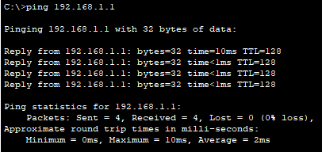

* PC1

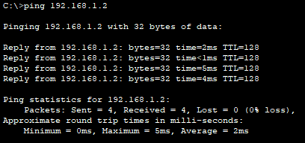

* PC2

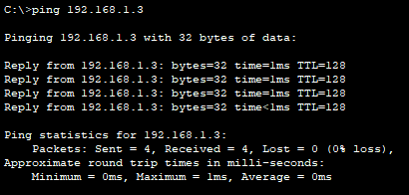

* PC2 – 192.168.1.3
* PC0

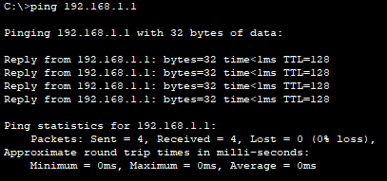

* PC1

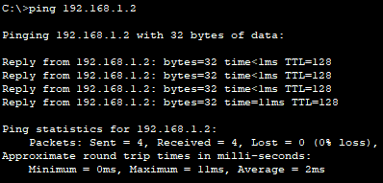

* PC2

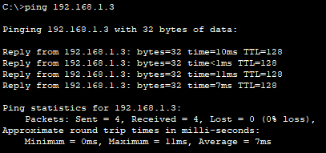

1. Menampilkan network address dan physical address di PC

PC0

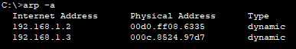

|  |  |  |
| --- | --- | --- |
|  | Network Address | Physical Address |
| PC1 | 192.168.1.0 | 00d0.ff08.6335 |
| PC2 | 192.168.1.0 | 000c.8524.97d7 |

PC1

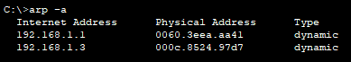

|  |  |  |
| --- | --- | --- |
|  | Network Address | Physical Address |
| PC0 | 192.168.1.0 | 0060.3eea.aa41 |
| PC2 | 192.168.1.0 | 000c.8524.97d7 |

PC2

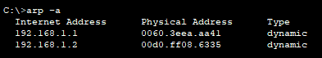

|  |  |  |
| --- | --- | --- |
|  | Network Address | Physical Address |
| PC0 | 192.168.1.0 | 0060.3eea.aa41 |
| PC1 | 192.168.1.0 | 00d0.ff08.6335 |

1. **Skenario 2**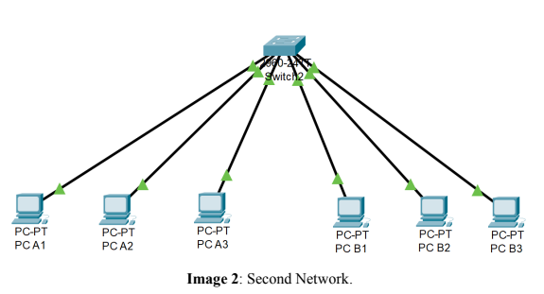
2. Create network as shown on Image 2. The IP Addresses and Subnet Masks of all PCs are shown on Table 4.

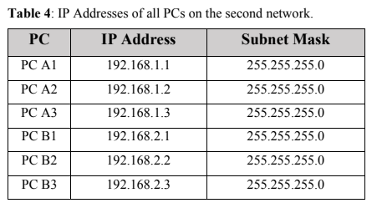

|  |  |
| --- | --- |
| PCA1 |  |
| PCA2 |  |
| PCA3 |  |
| PCB1 |  |
| PCB2 |  |
| PCB3 |  |

1. Do ping from each PC to all another PCs, and record the ping result, did it succeed or fail. Put ping results data on a matrix table as shown in Table 2.

* PCA1 **(192.168.1.1)**
  + Ping PCA1 192.168.1.1

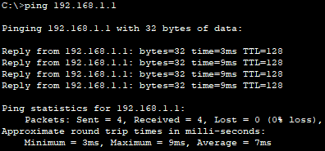

* + Ping PCA2 192.168.1.2

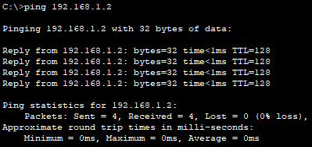

* + Ping PCA3 192.168.1.3

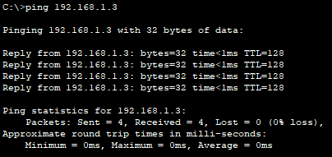

* + Ping PCB1 192.168.2.1

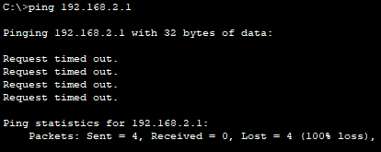

* + Ping PCB2 192.168.2.2

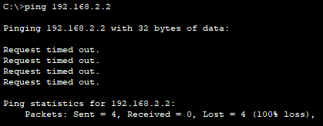

* + Ping PCB3 192.168.2.3

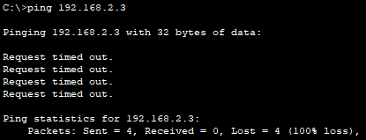

* PCA2 **(192.168.1.2)**
  + Ping PCA1 192.168.1.1

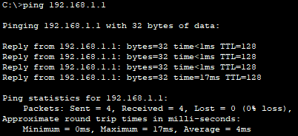

* + Ping PCA2 192.168.1.2

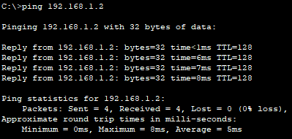

* + Ping PCA3 192.168.1.3

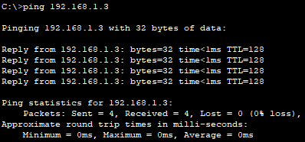

* + Ping PCB1 192.168.2.1

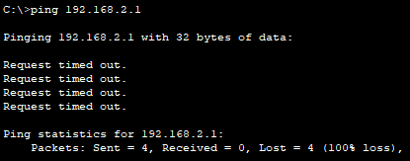

* + Ping PCB2 192.168.2.2

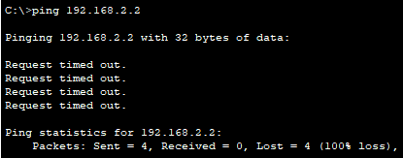

* + Ping PCB3 192.168.2.3

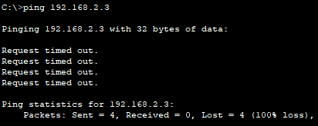

* PCA3 **(192.168.1.3)**
  + Ping PCA1 192.168.1.1

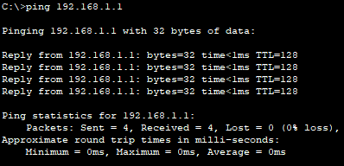

* + Ping PCA2 192.168.1.2

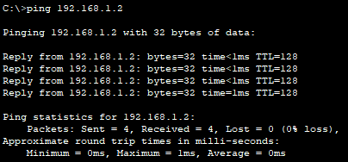

* + Ping PCA3 192.168.1.3

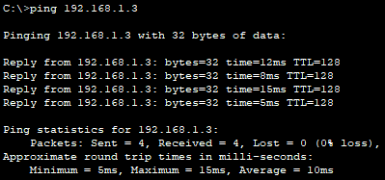

* + Ping PCB1 192.168.2.1

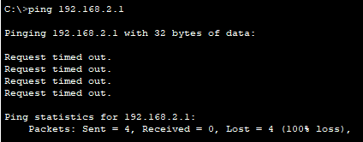

* + Ping PCB2 192.168.2.2

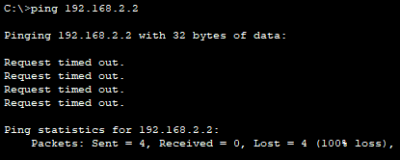

* + Ping PCB3 192.168.2.3

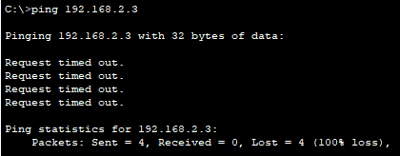

* PCB1 **(192.168.2.1)**
  + Ping PCA1 192.168.1.1

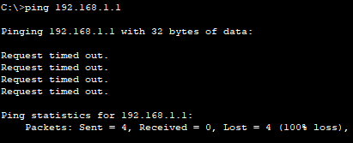

* + Ping PCA2 192.168.1.2

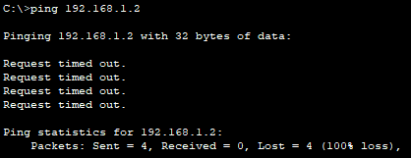

* + Ping PCA3 192.168.1.3

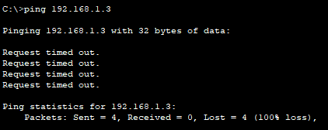

* + Ping PCB1 192.168.2.1

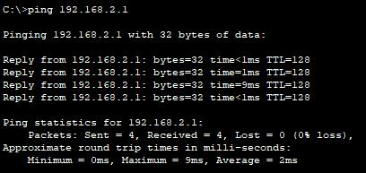

* + Ping PCB2 192.168.2.2

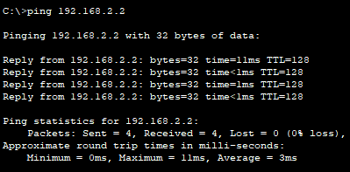

* + Ping PCB3 192.168.2.3

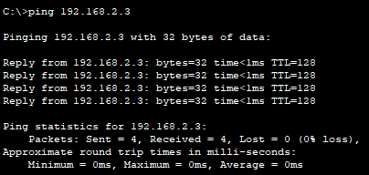

* PCB2 **(192.168.2.2)**
  + Ping PCA1 192.168.1.1

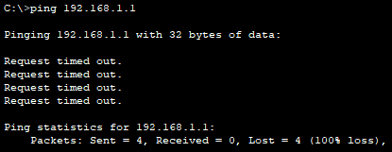

* + Ping PCA2 192.168.1.2

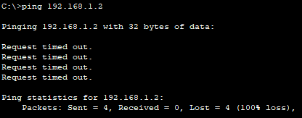

* + Ping PCA3 192.168.1.3

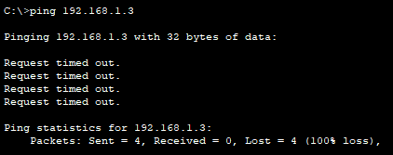

* + Ping PCB1 192.168.2.1

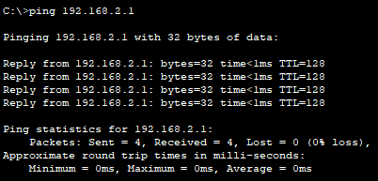

* + Ping PCB2 192.168.2.2

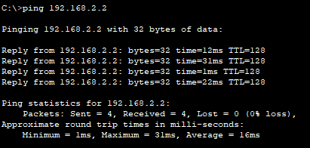

* + Ping PCB3 192.168.2.3

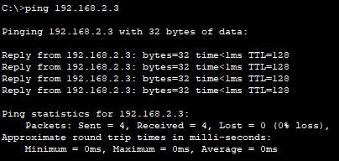

* PCB3 **(192.168.2.3)**
  + Ping PCA1 192.168.1.1

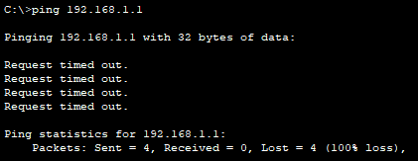

* + Ping PCA2 192.168.1.2

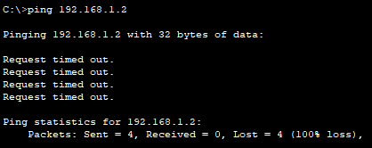

* + Ping PCA3 192.168.1.3

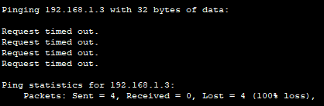

* + Ping PCB1 192.168.2.1

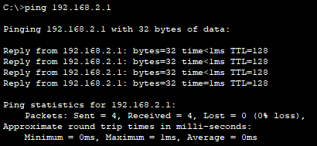

* + Ping PCB2 192.168.2.2

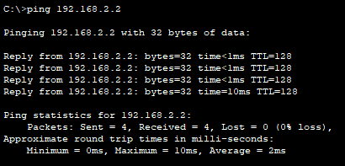

* + Ping PCB3 192.168.2.3

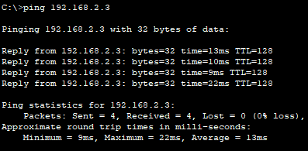

1. Show ARP table from PC A1, and record Network Addresses and Physical Addresses of all PCs that has been shown. Put Network Addresses and Physical Addresses data of all PCs that has been shown on a table as shown in Table 3.

PCA1

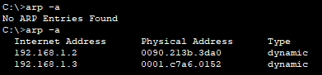

|  |  |  |
| --- | --- | --- |
|  | Network Address | Physical Address |
| PCA2 | 192.168.1.0 | 0090.213b.3da0 |
| PCA3 | 192.168.1.0 | 0001.c7a6.0152 |

1. Show ARP table from PC B1, and record Network Addresses and Physical Addresses of all PCs that has been shown. Put Network Addresses and Physical Addresses data of all PCs that has been shown on a table as shown in Table 3.

PCB1

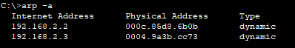

|  |  |  |
| --- | --- | --- |
|  | Network Address | Physical Address |
| PCB2 | 192.168.2.0 | 000c.85d8.6b0b |
| PCB3 | 192.168.2.0 | 0004.9a3b.cc73 |

1. **Skenario 3** 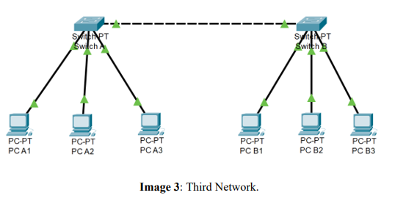
2. Create network as shown on Image 3. The IP Addresses and Subnet Masks of all PCs are shown on Table 5.

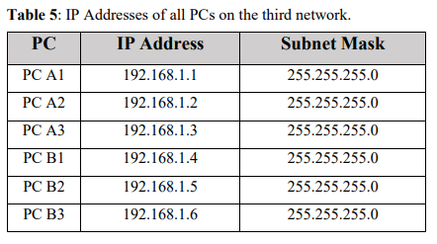

|  |  |
| --- | --- |
| PCA1 |  |
| PCA2 |  |
| PCA3 |  |
| PCB1 |  |
| PCB2 |  |
| PCB3 |  |

1. Do ping from each PC to all another PCs, and record the ping result, did it succeed or fail. Put ping results data on a matrix table as shown in Table 2.

* PCA1 **(192.168.1.1)**
  + Ping PCA1 192.168.1.1

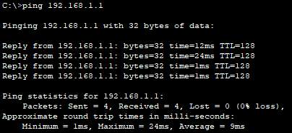

* + Ping PCA2 192.168.1.2

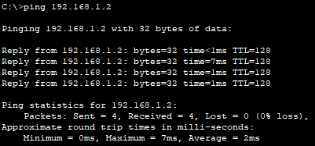

* + Ping PCA3 192.168.1.3

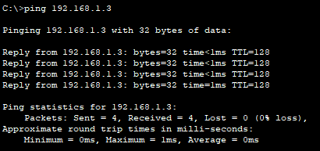

* + Ping PCB1 192.168.1.4

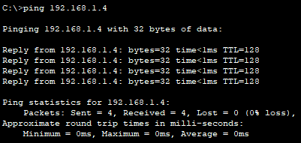

* + Ping PCB2 192.168.1.5

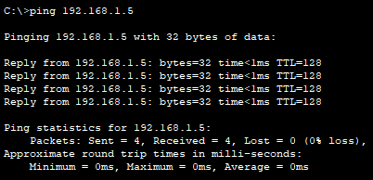

* + Ping PCB3 192.168.1.6

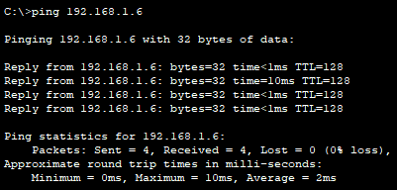

* PCA2 **(192.168.1.2)**
  + Ping PCA1 192.168.1.1

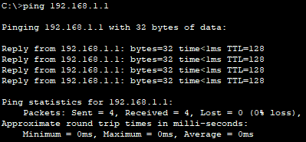

* + Ping PCA2 192.168.1.2

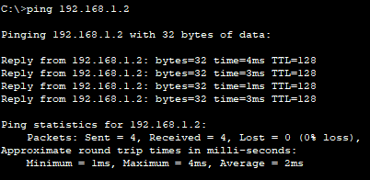

* + Ping PCA3 192.168.1.3

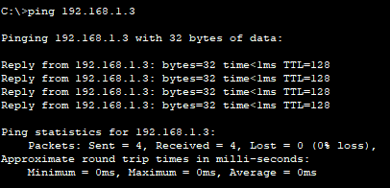

* + Ping PCB1 192.168.1.4

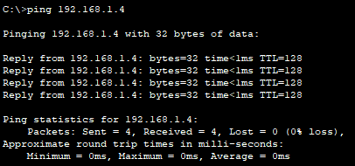

* + Ping PCB2 192.168.1.5

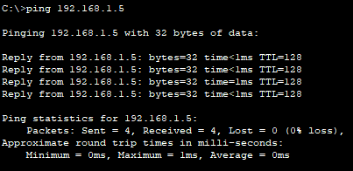

* + Ping PCB3 192.168.1.6

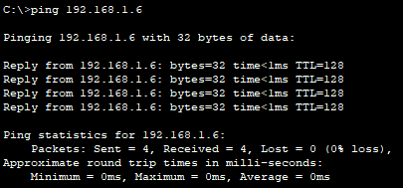

* PCA3 **(192.168.1.3)**
  + Ping PCA1 192.168.1.1

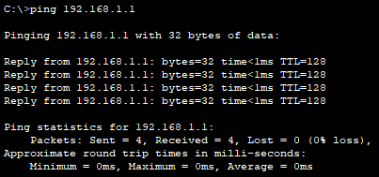

* + Ping PCA2 192.168.1.2

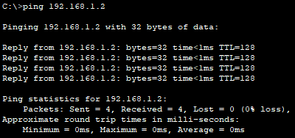

* + Ping PCA3 192.168.1.3

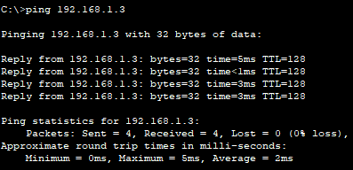

* + Ping PCB1 192.168.1.4

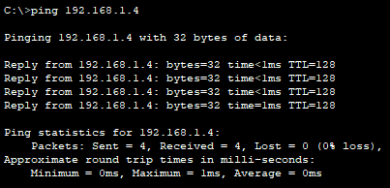

* + Ping PCB2 192.168.1.5

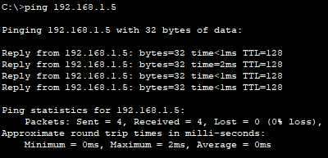

* + Ping PCB3 192.168.1.6

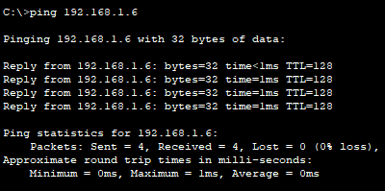

* PCB1 **(192.168.1.4)**
  + Ping PCA1 192.168.1.1

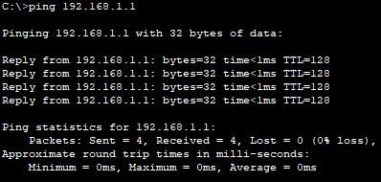

* + Ping PCA2 192.168.1.2

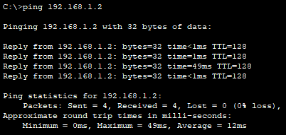

* + Ping PCA3 192.168.1.3

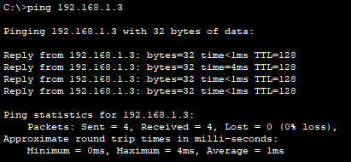

* + Ping PCB1 192.168.1.4

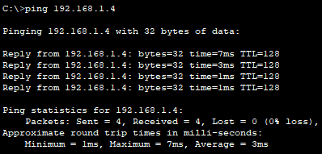

* + Ping PCB2 192.168.1.5

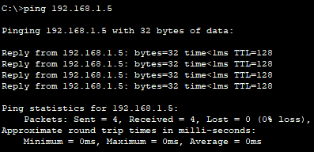

* + Ping PCB3 192.168.1.6

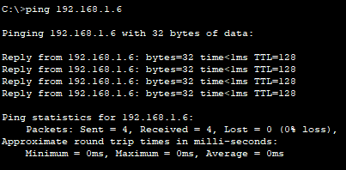

* PCB2 **(192.168.1.5)**
  + Ping PCA1 192.168.1.1

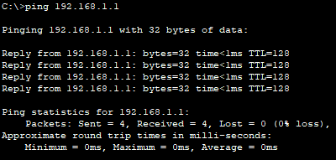

* + Ping PCA2 192.168.1.2

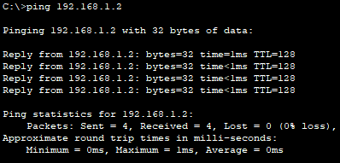

* + Ping PCA3 192.168.1.3

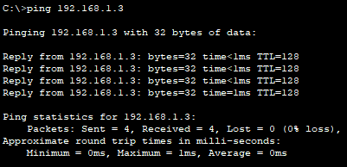

* + Ping PCB1 192.168.1.4

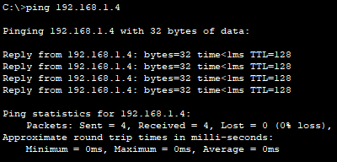

* + Ping PCB2 192.168.1.5

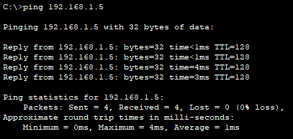

* + Ping PCB3 192.168.1.6

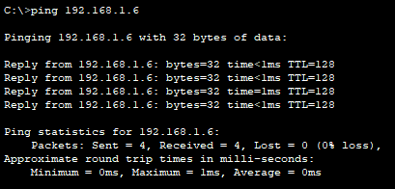

* PCB3 **(192.168.1.6)**
  + Ping PCA1 192.168.1.1

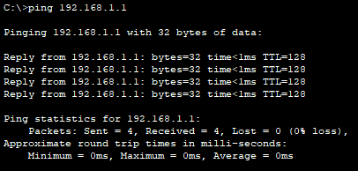

* + Ping PCA2 192.168.1.2

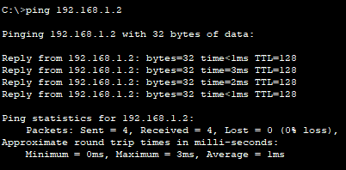

* + Ping PCA3 192.168.1.3

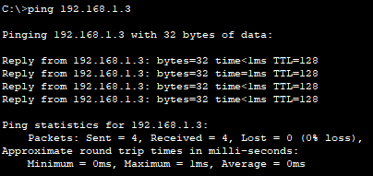

* + Ping PCB1 192.168.1.4

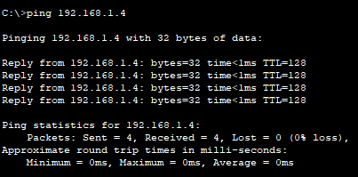

* + Ping PCB2 192.168.1.5

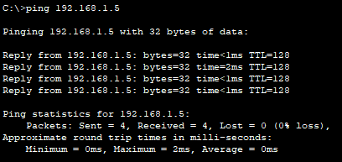

* + Ping PCB3 192.168.1.6

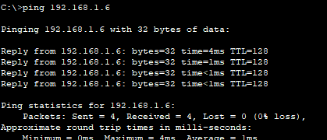

1. Show ARP table from PC A1, and record Network Addresses and Physical Addresses of all PCs that has been shown. Put Network Addresses and Physical Addresses data of all PCs that has been shown on a table as shown in Table 3.

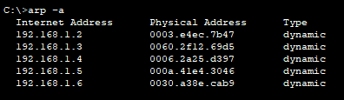

|  |  |  |
| --- | --- | --- |
|  | Network Address | Physical Address |
| PCA2 | 192.168.1.0 | 0003.e4ec.7b47 |
| PCA3 | 192.168.1.0 | 0060.2f12.69d5 |
| PCB1 | 192.168.1.0 | 0006.2a25.d397 |
| PCB2 | 192.168.1.0 | 000a.41e4.3046 |
| PCB3 | 192.168.1.0 | 0030.a38e.cab9 |

1. Show ARP table from PC B1, and record Network Addresses and Physical Addresses of all PCs that has been shown. Put Network Addresses and Physical Addresses data of all PCs that has been shown on a table as shown in Table 3.

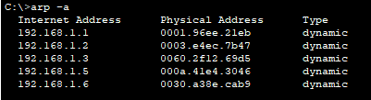

|  |  |  |
| --- | --- | --- |
|  | Network Address | Physical Address |
| PCA1 | 192.168.1.0 | 0001.96ee.21eb |
| PCA2 | 192.168.1.0 | 0003.e4ec.7b47 |
| PCA3 | 192.168.1.0 | 0060.2f12.69d5 |
| PCB2 | 192.168.1.0 | 000a.41e4.3046 |
| PCB3 | 192.168.1.0 | 0030.a38e.cab9 |

1. **The data obtained**

**Skenario 1:** 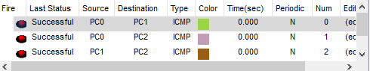

PC0

|  |  |  |
| --- | --- | --- |
|  | Network Address | Physical Address |
| PC1 | 192.168.1.0 | 00d0.ff08.6335 |
| PC2 | 192.168.1.0 | 000c.8524.97d7 |

PC1

|  |  |  |
| --- | --- | --- |
|  | Network Address | Physical Address |
| PC0 | 192.168.1.0 | 0060.3eea.aa41 |
| PC2 | 192.168.1.0 | 000c.8524.97d7 |

PC2

|  |  |  |
| --- | --- | --- |
|  | Network Address | Physical Address |
| PC0 | 192.168.1.0 | 0060.3eea.aa41 |
| PC1 | 192.168.1.0 | 00d0.ff08.6335 |

**Skenario 2:** 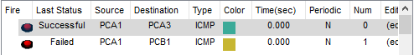 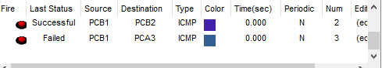

PCA1

|  |  |  |
| --- | --- | --- |
|  | Network Address | Physical Address |
| PCA2 | 192.168.1.0 | 0090.213b.3da0 |
| PCA3 | 192.168.1.0 | 0001.c7a6.0152 |

PCB1

|  |  |  |
| --- | --- | --- |
|  | Network Address | Physical Address |
| PCB2 | 192.168.2.0 | 000c.85d8.6b0b |
| PCB3 | 192.168.2.0 | 0004.9a3b.cc73 |

**Skenario 3: ** 

PCA1

|  |  |  |
| --- | --- | --- |
|  | Network Address | Physical Address |
| PCA2 | 192.168.1.0 | 0003.e4ec.7b47 |
| PCA3 | 192.168.1.0 | 0060.2f12.69d5 |
| PCB1 | 192.168.1.0 | 0006.2a25.d397 |
| PCB2 | 192.168.1.0 | 000a.41e4.3046 |
| PCB3 | 192.168.1.0 | 0030.a38e.cab9 |

PCB1

|  |  |  |
| --- | --- | --- |
|  | Network Address | Physical Address |
| PCA1 | 192.168.1.0 | 0001.96ee.21eb |
| PCA2 | 192.168.1.0 | 0003.e4ec.7b47 |
| PCA3 | 192.168.1.0 | 0060.2f12.69d5 |
| PCB2 | 192.168.1.0 | 000a.41e4.3046 |
| PCB3 | 192.168.1.0 | 0030.a38e.cab9 |

1. **Analysis.**

Skenario 1 : Dari skema jaringan pada skenario 1 hasil data yang diperoleh adalah bisa saling ping dan saling terhubung karena memiliki 1 jaringan yang sama. Pada menampilkan arp, ip/jaringan yang muncul adalah ip yang terhubung dengan ip PC tersebut.

Skenario 2 : Dari skema jaringan pada skenario 2 hasil data yang diperoleh adalah TTL dan RTO, hanya pc yang memiliki jaringan yang sama yang dapat saling terhubung/ping, sedangkan yang berbeda jaringan akan RTO / tidak dapat terhubung. Pada menampilkan arp, ip/jaringan yang muncul adalah ip yang terhubung dengan ip PC tersebut.

Skenario 3 : Pada skema jaringan skenario 3 semua pc dapat terhubung karena berada di satu alamat jaringan yang sama walau beda switcher, karena di skema ini switcher berfungsi sebagai penghubung dan penyebar dari device satu ke device lainnya. Pada menampilkan arp, ip/jaringan yang muncul adalah ip yang terhubung dengan ip PC tersebut.

1. **Conclution**

Dalam sebuah jaringan, terdapat beberapa perangkat atau device yang saling terhubung dan memiliki alamat Ip address dan network, jika sebuah jaringan berada di network yang sama maka device tersebut akan bisa saling terhubung namun jika berbeda network maka jaringan tidak dapat berhubung, perangkat switcher dapat berfungsi sebagai penghubung dan penyebaran relasi agar dari satu device bisa berhubungan ke lebih dari satu device lainnya. Ketika device di lakukan uji coba ping akan menampilkan pesan balik berupa TTL jika terhubung dan RTO jika tidak terhubung, ketika user mencoba menampilkan arp untuk mengecek ip yang terhubung maka dapat mengetik sintak “arp –a” untuk menampilkan seluruh jaringan yang terhubung pada device tersebut.